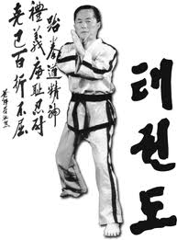
Taekwon-Do UK
Are pleased to invite you to our

6th Scottish Open Championships
Wishaw Sports Centre, Alexander Street
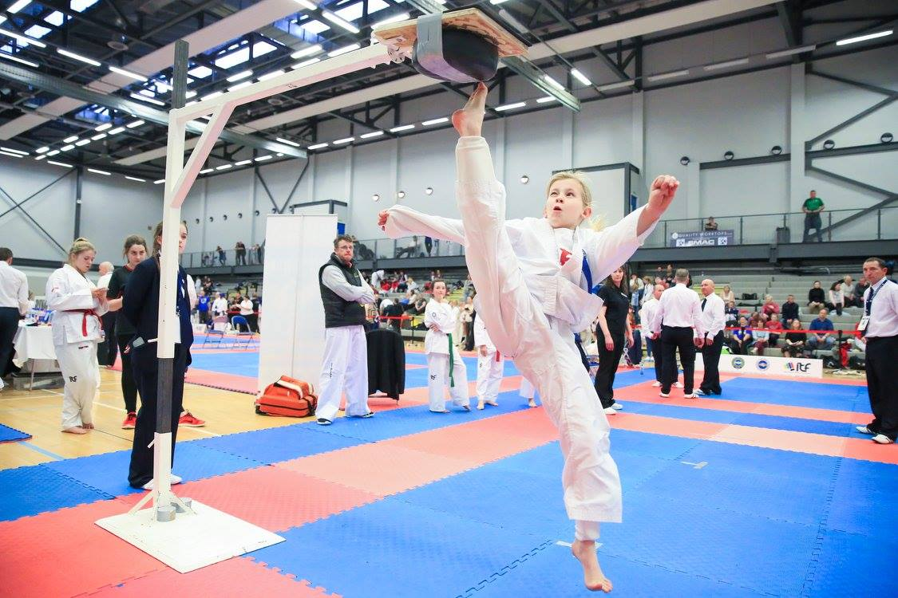
Wishaw, ML2 0HQ
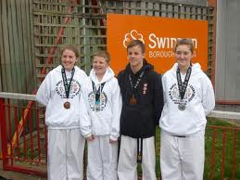
Open to Coloured and black belts
Saturday 19th May 2018

www.tkd-uk.com

ALL ENTRIES TO BE SUBMITTED to scotiatkd@aol.com

Dear Masters/Instructors /Students
On behalf of the Taekwon-Do UK executive, it gives me great pleasure to invite you to attend our Scottish Goodwill Open Championships. This Taekwon-Do event is open to coloured belt and Black belt competitors and is designed to unite TKD schools through our Martial Art of Taekwon-Do. These championships are a continuation of our successful International event held at Edinburgh four years ago with a big emphasis on fair play and light contact for competitors especially junior divisions to encourage scoring points rather than causing injury to your respected opponent.
Please note that as this is a goodwill event and we want each division to be as fair as possible, all junior categories will be designed on age, weight and height to keep physical and mental development as even as possible so please fill out entry forms correctly. Weigh in will commence prior to the sparring division starting.
I very much look forward to your attendance and promise as always I will help in any way that I can to ensure that your competition is a very enjoyable one. If anyone requires assistance with accommodation, entry forms, travel, party or any other aspect of our Taekwon-Do UK event, then please do not hesitate to contact me direct.
Associations are encouraged to submit referee’s at this event.
Good luck at these 2017 championships
Mr David Condie V
Taekwon-DoUK Director
Tournament Host
07825 333 432 scotiatkd@aol.com
Junior / Rainbow entry £20
Adult / Veteran Entry £20
Payment Methods
If paying by Cheque, Please send to our Scotia Academy Address one week prior to event or Bank Transfer
Account 00119386 S/C 83-28-21 using school name as reference

ALL ENTRIES TO BE SUBMITTED TO scotiatkd@aol.com

VENUE
Wishaw Sports Centre
Alexander Street
Wishaw
ML2 0HQ
PRICES
Junior 17yrs and Under £20
Adults 18 yrs and Over £20
Spectators £5 (Under 10yrs go free!)
Family Spectators £15 for 4 family members

Spectators can pay entry on the day
All competitor entry fees must be submitted with entry master sheet.
Please send all entries, Payments to
Scotia TKD
Unit 3 Tantallon Court
Castlehill Industrial Estate
CARLUKE
Scotland, UK
ML8 5UF
Master Sheet entries can be emailed to scotiatkd@aol.com

Categories
Coloured belt Pee Wee &Juniors
Patterns – Choice of competitors
Each belt will have its own pattern division and 5 age groups
MALE & FEMALE SEPERATE
10th + 9thKup white/yellow tag
8th + 7thKup Yellow/green tag
6th + 5thKup green/blue tag
4th + 3rdKup blue/red tag
2nd + 1stKup red/black tag
Age groups are
5yrs – 7yrs 8yrs – 10yrs 11yrs - 12 yrs 13yrs – 14 yrs 15 – 17yrs
Total 25 Pee Wee &junior coloured belt patterns division
Black Belt Juniors
Choice of competitors + Choice of judging panel
1st Degree Male 14 yrs and under 2nd Degree Male Patterns
1st Degree Male 15yrs – 17yrs
1st Degree Female 14yrs and under 2nd Degree Female Patterns
1st Degree Female 15yrs – 17yrs
Total 6 Junior Black Belt pattern divisions
Pee Wee & Junior Sparing ( All male and female separate in sparring)
White to green tag –point sparring Green to Black belt Continuous
Divisions will be
Grade
10th – 7thKup 6th – 4th Kup 3rd to 1stKup
Age
4yr-6yrs 7-9yrs 10-12yrs 13-14yrs 15-17yrs Coloured belt
Blackbelt Junior Sparring 14yrs and under 15yrs – 17yrs
JUNIOR MALE over 80kg,70-79kg,60-69kg,59 under JUNIOR FEMALE over 65kg, 55-64kg, 54 under

ADULTS
Patterns
Male 10th – 9thKup Female 10th – 9thKup
Male 8th – 7thKup Female 8th – 7thKup
Male 6th – 5thKup Female 6th – 5thKup
Male 4th -3rdKup Female 4th – 3rdKup
Male 2nd -1stKup Female 2nd – 1stKup
Blackbelt
Male 1st Degree Female 1st Degree
Male 2nd Degree Female 2nd Degree
Male 3rd Degree Female 3rd Degree
Male 4th + Degree Female 4th + Degree
Vet coloured 37-45yrs & 46yrs and above
Male 10th – 7thKup Female 10th -7thKup
Male 6th – 1stKup Female 6th – 1stkup
Vet Black Belt 37-45years & 46years and above
Male 1st Degree + Female 1st Degree +
Sparring Divisions
White to green tag points sparring
Green to black tag continuous sparring
Blackbelt continuous sparring
Male = micro light(-54kg), Light (-63kg), middle (-71kg) light heavy (-80kg), Heavy (+80kg)
Female = micro light(-52kg), Light (-58kg), middle (-63kg),Light Heavy (-70kg), Heavy (+70kg)
All weight divisions are subject to change depending on entry numbers, however the competitor will be
Notified of any changes before sparring matches begin.

Special Technique
Open to all juniors, the division will be the same as sparring division and will compete at flying high kick
Destruction
Open to all adult competitors, choice of judges destruction

IMPORTANT INFORMATION

ENTRY DEADLINE Saturday 11th May 2018 (strict)
Opening Ceremony 8.30am Sharp
Safety Equip Compulsory Gum Shield, Hands (closed ), Feet, Groin Guard, Head Guard
Also Body Guards will be available on Pee Wee squares where required.
Compulsory safety will be available to purchase on the day and also available to borrow on match squares.
Sparring bouts Junior 1min 30sec, adult 2 min, BB 2 min, (BB 2x2min in finals)

Please note we have staggered starting times to eliminate competitors and spectators waiting times. We will not commence a division until the starting time. The Black belts will be on first, then we will work in age groups and beginner belts first and finish with adults.

